# [***Law & Order: SVU EPs Tease 'Healing' Season 24 for Benson (and Stabler?), Introduce Newest Cop on the Beat***](https://tvline.com/lists/law-and-order-season-24-spoilers-benson-stabler/premiere-crossover/)

By [Kimberly Roots](https://tvline.com/author/kimberly-roots/) / September 20 2022, 1:57 PM PDT

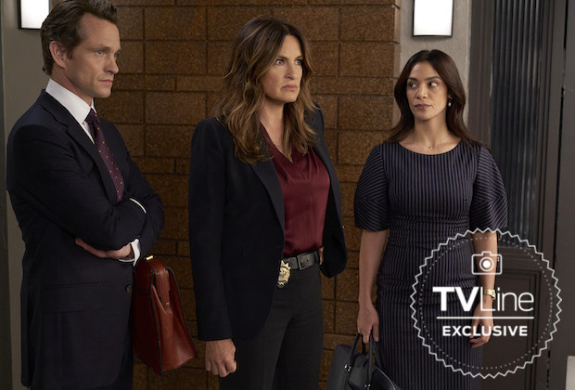

Courtesy of NBC

* [**0**](https://tvline.com/lists/law-and-order-season-24-spoilers-benson-stabler/#respond)

Capt. Olivia Benson, welcome to your season of #selfcare.

[*Law & Order: SVU*](https://tvline.com/tag/law-and-order-svu/)‘s precinct boss is known for being stalwart in the face of hard-hitting blows, both personal and professional. But the NBC procedural’s Season 24 — which gets underway Thursday as part of a [history-making, three-way crossover](https://tvline.com/2022/08/24/law-and-order-crossover-spoilers-svu-organized-crime-trailer-photo-nbc/) starting at 8/7c — will afford the Special Victims Unit boss and her co-workers some much-needed space to process.

“This show’s already had a two-tiered message, one of justice and one of moral complexity,” showrunner [David Graziano](https://tvline.com/tag/david-graziano/) tells TVLine. “And there’s going to be a slight third message, and that’s going to be one of healing.”

Executive producer [Julie Martin](https://tvline.com/tag/julie-martin/) adds that the real-world experience of living through a global pandemic has left its mark on the unit’s officers, as well as the community they police.

“It’s just tapping into the zeitgeist of what’s happening in New York City and across the country and across the world,” she says. “I mean, people are unsettled, still, by the events of the last three years.”

And if you’re Olivia, the hits and hurts go back a *lot* farther. So sure, we asked about William Lewis, and those pesky years that Stabler was gone. We also touched on more contemporary squad business, such as new hire Det. Grace Muncy (played by *Days of Our Lives*‘ Molly Burnett) and the future of ‘Rollisi’ which, as regular TVLine readers know, [recently got complicated](https://tvline.com/lists/kelli-giddish-leaving-law-and-order-svu-season-24-rollins/).

**Take a look at the exclusive crossover sneak peek photo above, then read on for the Season 24 scoop!**

## **The premiere crossover's 'emotional fallout'**

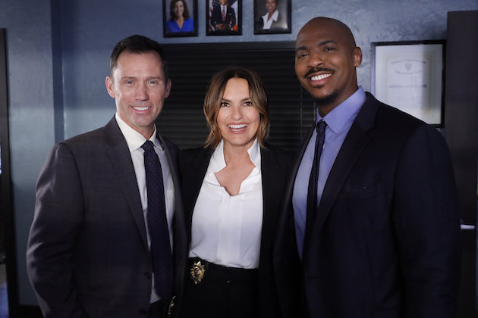

**Photo : Courtesy of NBC**

When TVLine talked with *Law & Order* showrunner Rick Eid in September, [he sketched out the overall shape](https://tvline.com/lists/law-order-season-22-preview-spoilers-roe-v-wade/three-way-crossover-svu-organized-crime/) of his show’s crossover premiere with *Law & Order: Organized Crime* and *SVU* (which will air in that order for premiere night only). Now, Martin gives us a little more detail about the plot.

“The case starts with a young girl who gets killed, and we quickly realize that she’s a trafficking victim,” the EP says. “Then SVU enters the scene and helps investigate that, and then the story does spin out into a bigger arena.”

Graziano adds that some aspects of the premiere will resonate in the rest of the season. In Episode 2 and beyond, the SVU detectives are “onto other things, but there’s one or two of them that are going to have some emotional fallout from the three-hour event that we have to honor, take seriously, dramatize and have some fun with,” he says.